SASEBO Waveform Acquisition
Quick Start Guide

[Ver. 0.9]



October 1st, 2010

National Institute of Advanced Industrial Science and Technology
Research Center of Information Security

Introduction
SASEBO Waveform Acquisition is a program to capture power consumption waveforms of an AES circuit on the SASEBO-GII board. This document explains; (1) how to use the oscilloscope Agilent DSO1024A for the waveform acquisition, and (2) how to use the program to save the waveform data into PC.

Preparation
The required hardware and software are as follows.
- SASEBO Acquisition installer, Setup.msi
- SASEBO-GII
- A control circuit binary, sasebo_gii_ctrl.mcs
- An AES circuit binary sasebo_gii_aes_comp_lx30.mcs
- PC (Windows XP/Vista/7)
- Digital Oscilloscope Agilent DSO1024A
- Two Agilent passive probes or one passive probe , 1 SMA cable, and SMA(female)-BNC(male) connector
- Two USB cables（type A-B）

Install SASEBO Waveform Acquisition
First, download SASEBO Waveform Acquisition Installer “Setup.msi” from a DPA contest page in the following SASEBO Website, and execute it.
http://staff.aist.go.jp/akashi.satoh/SASEBO/en/DPAcontest/index.html
The software requires an FTDI VCP/D2XX driver, Microsoft .NET Framework 3.5, and National Instruments NI-VISA 4.6.2. When the installation is completed, a new icon is created on the desktop as shown in Fig. 1. Please refer “SASEBO-GII Quick Start Guide” on the following URL for details.
http://staff.aist.go.jp/akashi.satoh/SASEBO/pdf/SASEBO-GII_QuickStartGuide_Ver1.0_English.pdf
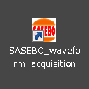
Fig. 1 Icon of SASEBO Waveform Acquisition

Setup SASEBO-GII
Download binary files of the control circuit (sasebo_gii_ctrl.mcs) and an AES circuit (sasebo_gii_aes_comp_lx30.mcs) from the DPA contest page in the SASEBO Website. After that, configure Spartan-3A XC3S400A and Virtex-5 LX30 XC5VLX30 with the control and AES circuits, respectively. Please refer to the “SASEBO-GII Quick Start Guide” for configuration details.

Capture waveform data
- Configure system clock to 2 MHz
Power off SASEBO-GII and set the DIP switch SW7 on the board as shown in Fig. 2 to set an operating frequency of 2MHz.
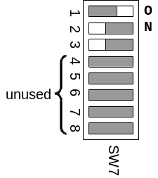
Fig. 1 Configure operating frequency by SW7

- Connect SASEBO-GII and DSO1024A to the PC using USB cables.
- Connect probes to SASEBO-GII
Channel 1: TP2 (GND to TP5)
Channel 2: 1st pin of J6 (GND to the brace on the corner)．
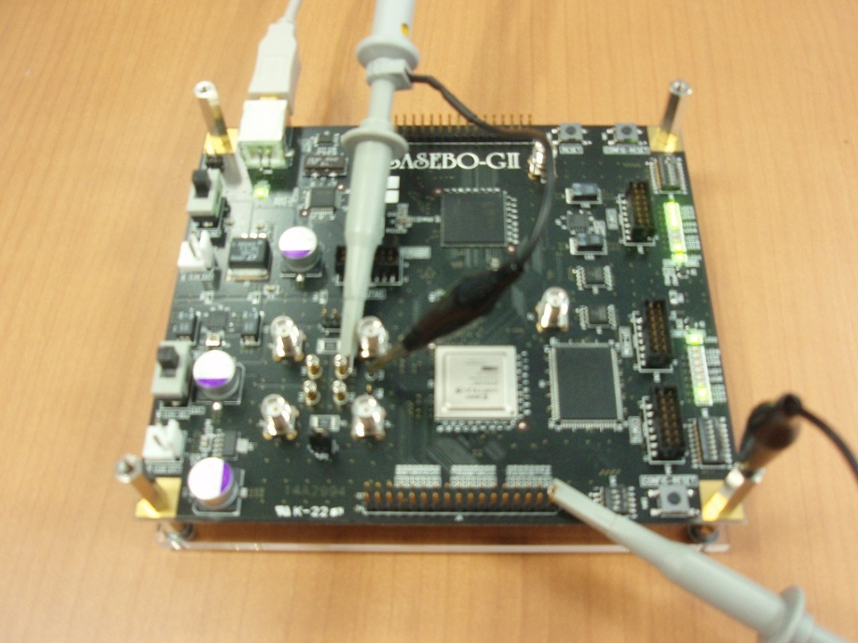
TP2
TP5
J6
GND
Fig. 2 Measurement using two probes
For using only one SMA cable on the channel 1, connect it to J2 as shown in Fig. 3.
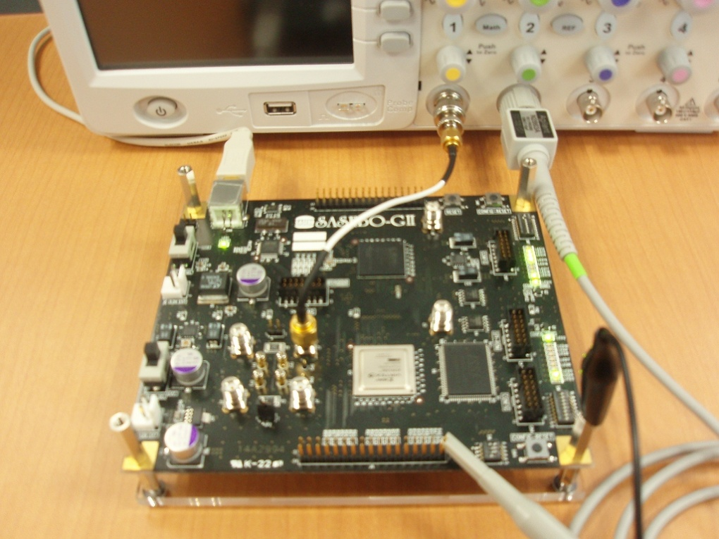
J2
J6
GND
Fig. 3 Measurement using one probe and one SMA cable
- Power up DSO1024A．
- Power up SASEBO-GII.
- Launch SASEBO Waveform Acquisition program.
When the oscilloscope DSO1024A is recognized by the program, USB0:XXXX…” is displayed on the “Oscilloscope” box as shown in Fig. 5. If DSO 1024 A is not recognized, a message “Oscilloscope is not ready!” is displayed.
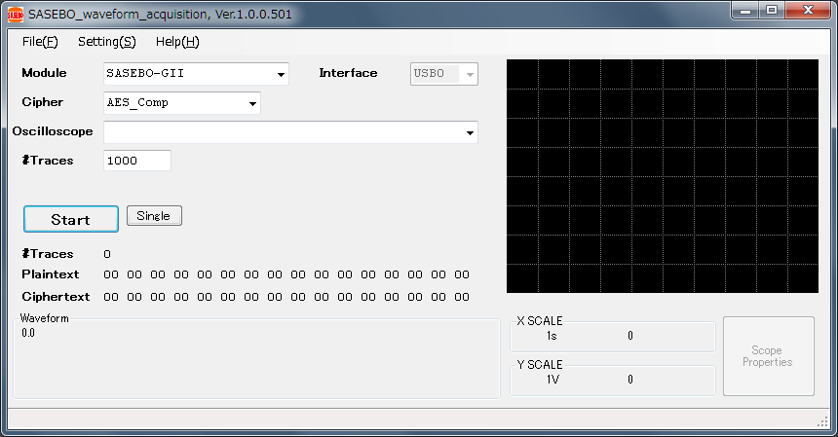
Fig. 5 Initial window of SASEBO Waveform Acquisition

- Configuration of the oscilloscope.
Click the “Scope Properties” button for configuration of the oscilloscope and set parameters as follows. Optimal values vary depending on the type of the probes, and thus adjustments would be required according to user environment.
XOffset: 2.8E-06
XRange: _500ns
YOffset: -1.03
YRange: _5mV
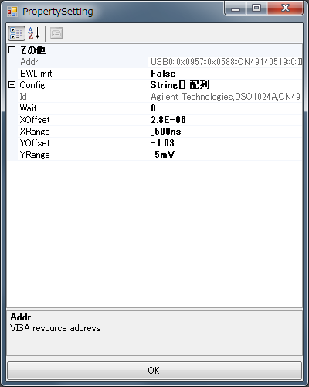
Fig. 6 Configuration window for oscilloscope
- Check the oscilloscope settings.
Click the “Single” button to get a single waveform, and check whether the waveform fits in the window.
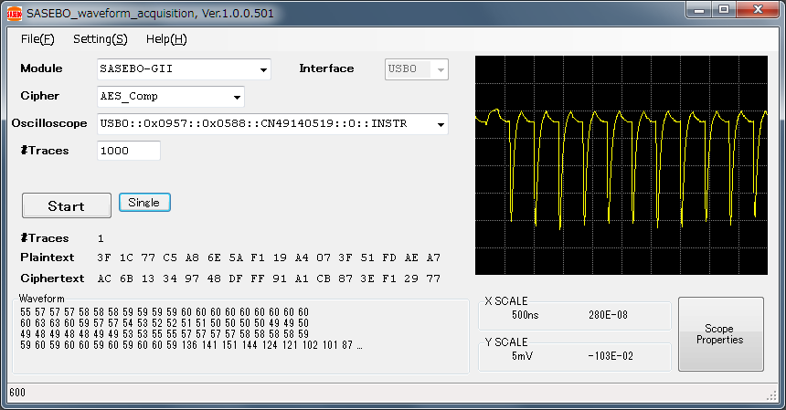
Fig. 7 Waveforms with a SMA cable and a 500-Ω pass-through terminator

- Start waveform acquisition
Indicate the number of traces to be captured in the “#Traces” box, and click the “Start” button. When the waveform acquisition process is completed, waveform data are stored in the following folder, where YYYY, MM, dd, HH, mm and ss are timestamp.
“\Users\[user]\MyDocuments\SASEBO_Aquisition\wf_gii_yyyy_MM_dd_HHmmss”

Appendix

- System clock setting on SASEBO-GII (SW7)
Table. 1 SW7 Configuration
Value | SW7 | Operating  Frequency | Value | SW7 | Operating  Frequency
0 | 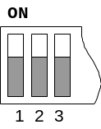 | 24MHz | 4 | 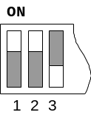 | 4MHz
1 | 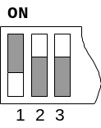 | 12MHz | 5 | 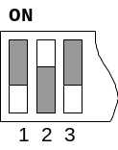 | 3MHz
2 | 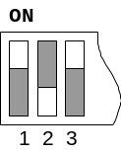 | 8MHz | 6 | 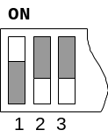 | 2MHz
3 | 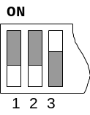 | 6MHz | 7 | 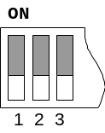 | 1MHz

- SASEBO Waveform Acquisition Menu

File(F)
Quit the program. The current oscilloscope setting is stored as a data file under “My documents\SASEBO_Acquisition” folder. Its file name is a VISA resource address name.

Setting(S)

Activate Scope
When it’s checked on, the oscilloscope is activated. When it’s checked off, the oscilloscope is inactivated, and the program doesn’t send a request for waveform acquisition.

Remote Scope
When a hostname or an IP address is indicated in a “Host” parameter, communication on VISA over TCP/IP will be available.

Help(H)

About(A)
Display the version information of the program.
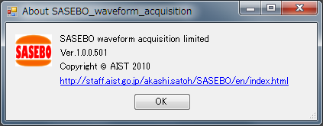
Fig. 4 Version information

Property setting window
Optional settings for the oscilloscope can be set at “Config” property.

